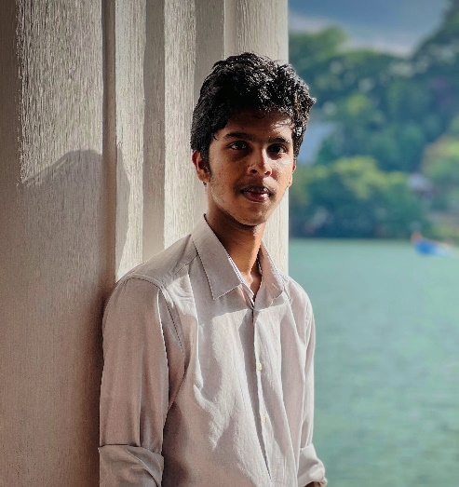Vijayan Gobiharan

1/1, Temple Road Kengalla, Sri Lanka

**Contact info**

What’s app: +94 764691651 **|** Email: [gobiharanVijayan@Gmail.com](mailto:gobiharanVijayan@Gmail.com)

NATIONALATY : Sri Lanka

Date of birth : 03 November 2003

Gender : Mail

LinkedIn : <https://rb.gy/28eidy>

**About me**

I enjoy working with Java and building front-end projects. Aside from coding, I have a keen interest in astronomy, finding joy in exploring the stars.

Through my studies, I've honed my problem-solving skills on diverse projects, emphasizing user-friendly solutions. I'm eager to contribute my skills and passion for technology to your team, confident that my dedication and practical experience will be valuable.

**Skills**

* Front End development
* Html
* CSS
* Bootstrap
* JavaScript
* Android studios
* Leadership
* Groupwork
* Java
* Nature Photography
* Observation Astronomy
* UI/UX

**PROFESSIONAL QUALIFICATION**

* HND in software engineering in Bcas Kandy campus. (Pearson standard) on going……
* completed a Diploma in English and IT at BCAS Kandy Campus.
* Completed a Diploma in Software engineering at NIBM Kandy Campus.
* O/L (ordinary level) (2021) I received one B, five Cs, and three S in my grades. I'm particularly pleased with the C in math and passing grade in science.

**Projects**

Academic Projects

* Software project for Asri hospital. (Suggestion).
* Website and an Application for a biscuit company.

**EXTRA CURRYCULER ACTIVITES**

* Astronomy Club -Participated in regular stargazing sessions and discussions on celestial phenomena."
* Prefect in Rajawella hindu national collage.
* Tesla Club - Explored Electric Vehicle Technology, Renewable Energy.
* SpaceX Club -Studied Rocketry Principles, Space Exploration.
* AI Club-Explored Artificial Intelligence (AI) Concepts and Applications

**DECLARATION**

I confirm that the information provided is true and correct to the best of my knowledge and ability.

2024-04-23 Vijayan Gobiharan

Date Signature of applicant